Trafficked Teen Girls Describe Life In 'The Game'
by Youth Radio
December 6, 2010

Listen to the Story
All Things Considered
[12 min 29 sec]
- Add to Playlist
- Download
- Transcript

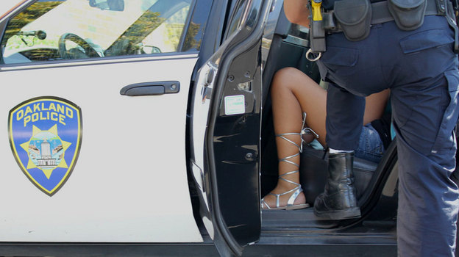
Enlarge Brett Myers /Youth Radio
Oakland, Calif., in the San Francisco Bay Area, has been dubbed by the FBI as a "high-intensity child prostitution area." Oakland officials say that a third of teenage girls working in prostitution there were abducted and forced onto the streets, and 61 percent of teen prostitutes say they were raped as children.
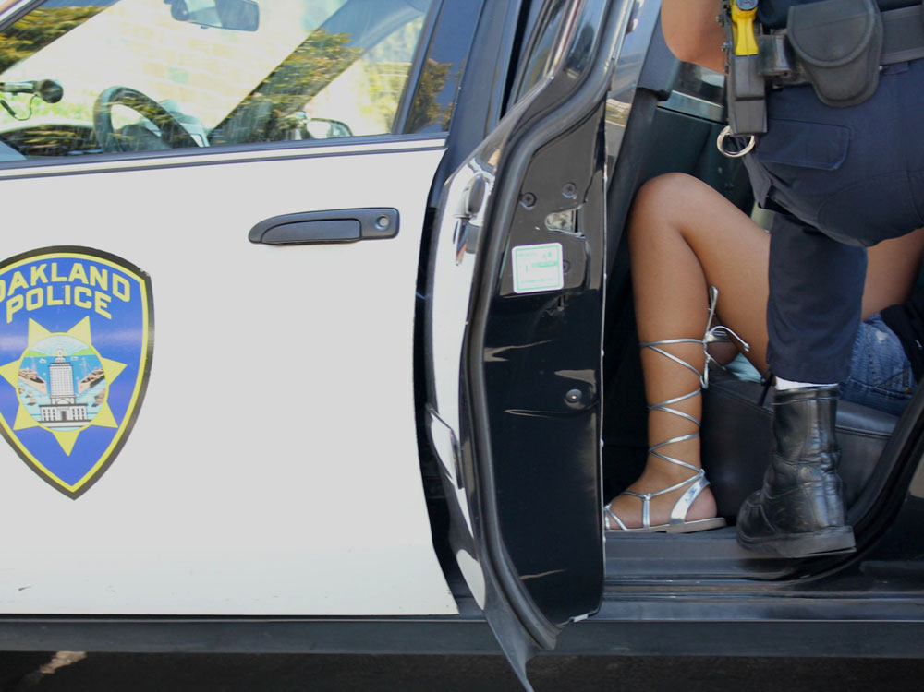
Brett Myers /Youth Radio
Oakland, Calif., in the San Francisco Bay Area, has been dubbed by the FBI as a "high-intensity child prostitution area." Oakland officials say that a third of teenage girls working in prostitution there were abducted and forced onto the streets, and 61 percent of teen prostitutes say they were raped as children.
text size A A A
December 6, 2010
Part 1 of 2
Youth Radio is an independent producer. For more than six months, the organization has been investigating child sex trafficking in Oakland, Calif. In this two-part report, it pieces together what life is like for girls who are forced into prostitution — and how law enforcement continues to criminalize girls the state legally defines as sexually exploited victims.
Last month, the FBI announced the results of Operation Cross Country V, a 40-city investigation that led to the rescue of 69 children who were being victimized through prostitution. More than 800 people, including 99 pimps, were arrested.
According to the FBI, more than 100,000 children are sold for sex in the U.S. each year. In a two-part series, Youth Radio takes a look at the problem of child prostitution in the U.S. Today, two young women who recently escaped what's called "the game" share their stories.
"I'd wake up at 5; I'd be outside by 5:30," says Brittney, 19. "I would just wait and see what happened, whether it'd be in the streets or whether I'd be on the Internet. And then I won't be able to come back inside until like 2 o'clock in the morning, so I'd get only, like, three hours of rest."
Brittney, a former sex worker, agreed to share her story under the condition that her real name not be used. She's a native of Oakland, Calif., and only recently out of what's called "the game." Less than a year ago, Brittney was being forced to work as a prostitute on the Internet and on the streets of Oakland.
"I got kidnapped when I was 15," says Brittney. "I decided to cut school one day. I was in Oakland, on Havenscourt and Foothill, and all I heard was, 'Man, go get that girl!' And one of them came out and dragged me by my hair, and he pulled me into the car."
Child Prostitution In The U.S., By The Numbers
100,000-300,000: The number of children sold for sex in the U.S. each year
12-14: The average age at which girls first become victims of prostitution
11-13: The average age at which boys and transgendered youth enter into prostitution
55 percent: The proportion of girls living on the streets in the U.S. engaged in formal prostitution
30 percent: The proportion of youth living in shelters who are sexually exploited
75 percent: The proportion of girls engaged in prostitution who are working for a pimp
One-fifth: The fraction of exploited children who are trafficked nationally
$150,000-$200,000: The amount a pimp can make each year, per child
76 percent: The proportion of transactions for sex with underage girls conducted via the Internet
Sources: Justice Department, National Center for Missing and Exploited Children, Demi & Ashton Foundation
Brittney was the victim of a so-called guerrilla pimp — a person, usually a man, who uses force and fear to traffic women, many of whom are underage. Oakland police estimate that a third of teenage girls working in prostitution were abducted and forced onto the streets the way Brittney was.
She says that after she was kidnapped, at least six men gang-raped her. She was then driven to Sacramento, where her 32-year-old pimp put her out on the street as a prostitute. He took her phone, told her not to talk to anyone but "johns," and had his sister watch her so she wouldn't run. She was shuttled back and forth to work Oakland's red-light district.
A 'Romeo Pimp'
Darlene, whose name has been changed as well, came into "the game" a different way.
She entered her teens around the same time her native Oakland, as part of the San Francisco Bay Area, was named by the FBI as one of the 13 national hot spots for child prostitution.
Classmates talked about their boyfriends who had lots of money, and — like most kids in the Bay Area — she listened to music by Oakland rappers, whose lyrics about pimping glamorized "the game."
"A lot of it is glorified," says Darlene. "Oh, you're from Oakland. Everybody has dreads; everybody goes dumb; we pop pills, smoke a lot of weed; parties, sideshows and hos."
If you're not part of the scene, it's hard to believe that prostitution has become normal for so many in Oakland and other cities. But many see it as an alternative to desperate home lives, friends getting shot, no food on the table and absent parents. And pimps take advantage of that.
Darlene became a prostitute at the hands of what Oakland police call a "Romeo pimp." Now 18, she moved in with her boyfriend when she was 14, after she was kicked out of the house.
"On my 15th birthday, he was like, 'Well, you know, since you'll be staying with me, we need more food. We need to find a way to get some money'," says Darlene. "He's the one that, like, introduced me to prostitution, and I didn't see anything wrong with it."
Darlene says she later found out her then-18-year-old boyfriend had pimped other girls before. When he became her pimp, Darlene says, he told her what to do to make money. " 'This is how you look at the guys; this is what you tell them; these are what cars to stay away from; this is how much you charge.' "
On 'The Track'
International Boulevard, one of Oakland's busiest streets, is what pimps call "The Track." In a 50-block span on one recent day, there were some 20 girls. Some of them were posted on street corners; others were hanging by bus stops, or just walking the same blocks over and over.

National Hot Spots
In 2003, the FBI's Crimes Against Children Unit identified these 13 U.S. cities as having a high incidence rate of child prostitution.
- Los Angeles
- Minneapolis
- Dallas
- Detroit
- Tampa, Fla.
- Chicago
- San Francisco
- San Diego
- Miami
- New York City
- Washington, D.C.
- Las Vegas
- St. Louis
Source: FBI
The guys who work at one of the many taco trucks on International Boulevard say that every day, pimps use their parking lot to drop off girls and hang out. They say it's common to see pimps beating girls.
While most Oakland residents drive by and don't think twice about what's going on here, the people in this neighborhood do.
"They're always there," says Frank Pardo, whose mother owns Yoyi's Bridal shop. "You always see them, and some of them are quite beautiful, looking like straight models."
Just down the street, a teenage girl in a short red dress is crying on a bench. She has blood coming from her mouth. A business owner who runs a clothing store says he saw the whole thing: The man who punched the girl appeared to be her pimp, and stole her purse.
The witness would not identify himself by name, for fear of retribution from sex traffickers. That's the same reason he gave for not calling the police.
Brittney and Darlene each survived the many months they spent turning tricks on International Boulevard and meeting johns through the Internet. Brittney says her pimp got her hooked on drugs to keep her working around the clock and eating only one meal a day, usually a burger from McDonald's.
"It's not the best deal to have sex with 15 different guys in one day and only get a cheeseburger at the end of it," says Alameda County Assistant District Attorney Sharmin Bock. Bock compares the girls' situation to being brainwashed by a cult.
"Remember Guyana and Jim Jones, where everybody's drinking that Kool-Aid drink? Well, that's exactly what these girls have had. Let's call it pimp juice. They've all had it, and they can't see past either their affection for their trafficker, or their fear of him," says Bock.
A History Of Violence
According to a recent survey of social service providers in Oakland and the rest of the county, 61 percent of the teen prostitutes they see say they were raped as children.

Read More From Youth Radio
A Youth Radio Investigation: Trafficked
That's what happened to Brittney. She says she was raped by her stepfather and years later by her trafficker. Brittney tries to understand how she kept going back to her pimp.
"I knew what he was capable of," she says. "He'd beat me and he'd rape me, he'd beat me and he'd rape me, and I just kept going back until I ended up being pregnant by him. And he beat me so bad that I ended up having a miscarriage."
"I got shot at quite a few times," says Darlene, who had been arrested for prostitution and robbery in the year after she ran away from her father's house. She wanted to go home.
"I used to fantasize about boys that are gangstas. 'Oh, they get hecka money and they're just gangsta and cute, and it's cool,' " says Darlene. "That's OK when you're in high school. After that, what are you gonna do with your life? You're gonna be in jail or you're gonna be dead, and I don't want part of either one of those."
A New Life
After her last arrest, Darlene joined a program that transitions girls off the streets. Brittney got out, too, shortly after she had the miscarriage.
"Six days later — it was a Sunday — and he put me on East 14th. I told him that I didn't want to be out on Sundays because I had a bad feeling about Sundays. And I saw my aunt. And my aunt ended up snatching me up and putting me in the car. And then she took me to my mom's house," says Brittney.

Web Resources
The Demi & Ashton Foundation
FBI's Innocence Lost National Initiative
National Center For Missing And Exploited Children, CyberTipline
"Two days later, police came knocking on my door, saying I had a warrant."
That warrant put Brittney back in jail for prostitution and, like Darlene, she enrolled in a community program.
It's been less than a year since Brittney and Darlene turned their lives around. Now they are both working with community organizations to help other girls escape sex trafficking. Darlene and Brittney consider themselves survivors, navigating a new life.
"I got back in school and I graduated high school with, like, 20 extra credits," says Darlene, who has two jobs and is planning to attend college. "When I was 15, I didn't see myself alive at the age of 18. And now I am 18, and I can look back and say, 'You know, I've been through all that, and I've come out of it.' It feels wonderful."
Tomorrow on All Things Considered, Youth Radio explores what local police and the FBI are doing to combat sex trafficking.

